**MODULE 1**

**Chapter 1: An Overview of Business Intelligence, Analytics, Data Science, and AI**

**Changing Business Environments and Evolving Needs for Decision Support and Analytics**

**Introduction**

Organizations operate in a **complex, rapidly changing environment** that creates both **opportunities** and **threats**. The **changing business environment** forces organizations to respond quickly and effectively to survive and thrive. Decision makers must be **aware of environmental factors**, assess their potential impact, and react in a timely manner. Computerized decision support has become essential to help managers cope with this complexity and speed of change.

**Decision-Making Process**

**Definition**

Decision making is a **process of choosing among two or more alternative courses of action** for the purpose of attaining a goal or goals. It is an **essential managerial activity** at all levels of an organization.

**Steps in the Decision-Making Process**

1. **Define the Problem**
   * Understand the difference between the actual state and the desired state.
   * Poorly defined problems can lead to ineffective solutions.
2. **Identify Alternatives**
   * List possible courses of action that could solve the problem.
3. **Determine the Criteria**
   * Establish measures to evaluate the alternatives.
4. **Evaluate the Alternatives**
   * Assess each option using the established criteria.
5. **Choose the Best Alternative**
   * Select the course of action that best meets the decision criteria.
6. **Implement the Decision**
   * Put the chosen solution into effect.
7. **Monitor and Evaluate the Results**
   * Compare actual outcomes with expected results and make adjustments if needed.

**Factors Affecting Decision-Making Today**

* **Time pressure** due to fast-changing conditions.
* **Large amounts of data** that must be processed quickly.
* **Complexity** of global operations and multiple variables.
* **Uncertainty** about the future and incomplete information.

**Technologies for Data Analysis and Decision Support**

Modern organizations rely on **advanced technologies** to support decision-making at all levels.

**1. Data Warehousing**

* Integrates data from multiple internal and external sources into a **central repository**.
* Enables consistent, accurate, and timely reporting.

**2. Online Analytical Processing (OLAP)**

* Allows users to analyze data in **multiple dimensions**.
* Supports **drill-down** (detailed view) and **roll-up** (summary view) operations.

**3. Business Analytics**

* Encompasses descriptive, predictive, and prescriptive analysis.
* Uses statistical and machine learning models to gain insights.

**4. Big Data Technologies**

* Handle **large, diverse, and rapidly growing datasets**.
* Examples: Hadoop, Apache Spark.

**5. Artificial Intelligence (AI) and Machine Learning (ML)**

* AI systems can learn from historical data to improve predictions and automate decisions.

**6. Data Visualization Tools**

* Present data using **charts, graphs, dashboards** to make insights more understandable.

**Decision-Making Processes and Computerized Decision Support Framework**

**Introduction**

Decision making is at the **core of managerial activities**. It involves choosing among alternative courses of action to achieve desired outcomes.  
Given the complexity of modern organizations, **computerized decision support** is now essential to assist managers in processing large amounts of data, modeling complex scenarios, and selecting optimal actions.

**Simon’s Process: Intelligence, Design, and Choice**

**Overview**

Herbert A. Simon, Nobel laureate in Economics, proposed a **three-phase model** for decision making:

1. **Intelligence Phase** – identifying problems or opportunities.
2. **Design Phase** – developing possible solutions.
3. **Choice Phase** – selecting the most appropriate solution.

Later, researchers added the **Implementation Phase** as a fourth step.

**The Intelligence Phase: Problem (or Opportunity) Identification**

**Purpose**

To **scan the environment**, detect conditions that require decisions, and **diagnose the problem**.

**Activities in This Phase**

* **Problem detection**: Recognizing gaps between actual and desired performance.
* **Data collection**: Gathering relevant internal and external data.
* **Problem classification**: Determining whether the problem is structured, semi-structured, or unstructured.
* **Problem ownership**: Deciding who is responsible for resolving the issue.

**Example**

A retail chain detecting declining customer satisfaction scores via feedback surveys.

**Analytics in Action 1.1: Making Elevators Go Faster!**

**Case Summary**

* **Problem**: Tenants in a high-rise building complained elevators were too slow.
* **Initial thinking**: Install faster elevators — costly and complex.
* **Analytical approach**: Redefine the problem — dissatisfaction was due to perceived wait time.
* **Solution**: Install mirrors near elevators so people are distracted while waiting.
* **Lesson**: Proper **problem definition in the Intelligence Phase** can lead to innovative, cost-effective solutions.

**The Design Phase**

**Purpose**

To **develop and analyze possible courses of action** to address the identified problem or opportunity.

**Activities**

* Formulating **models** of the decision problem (mathematical, simulation, descriptive).
* Generating **alternatives** for consideration.
* Predicting the consequences of each alternative.
* Conducting **what-if** and **sensitivity** analyses.

**Example**

A logistics company simulating different delivery routes to minimize costs and delivery times.

**The Choice Phase**

**Purpose**

To select the **best course of action** from the alternatives generated in the design phase.

**Activities**

* Evaluating each alternative against established criteria.
* Applying optimization or decision analysis tools (e.g., decision trees, cost-benefit analysis).
* Making the final selection.

**Example**

Choosing the most profitable product mix given limited production resources.

**The Implementation Phase**

**Purpose**

To put the chosen solution into action and ensure that it is producing the desired results.

**Activities**

* Allocating resources and assigning responsibilities.
* Managing change and overcoming resistance from stakeholders.
* Monitoring outcomes and making adjustments as needed.

**Example**

Rolling out a new customer relationship management (CRM) system after careful planning and training.

**Diagram Explanation**

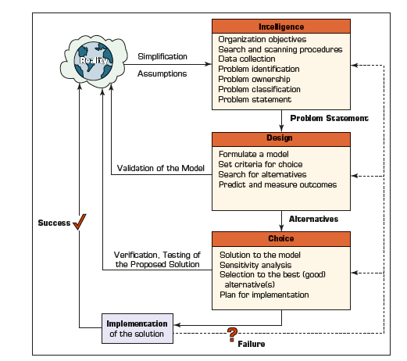

The figure for this section illustrates **Simon’s decision-making phases** in a linear but iterative process, showing feedback loops between phases to allow for reassessment when necessary.

**Evolution of Computerized Decision Support to Analytics/Data Science**

**Introduction**

Computerized decision support has evolved significantly over the past five decades.  
Initially, systems were developed to **produce routine reports** for managers, but over time they have become **interactive, analytical, and data-driven platforms** supporting complex, real-time decision making.  
The evolution reflects advancements in **technology, data storage, processing power, and analytical techniques**.

**Stages of Evolution**

**1. Management Information Systems (MIS) – 1960s to early 1970s**

* Focused on producing **structured, periodic reports** based on internal data.
* Provided **historical summaries** but limited analytical capabilities.
* **Limitations**: Static, inflexible, and mainly for operational control.
* **Example**: Weekly sales summary reports generated from transaction systems.

**2. Decision Support Systems (DSS) – late 1970s to 1980s**

* Designed to assist in **semi-structured and unstructured decision making**.
* Integrated **analytical models** with data to support “what-if” and sensitivity analysis.
* More **interactive** than MIS, allowing managers to explore data and test scenarios.
* **Example**: A DSS for selecting the best plant location based on cost, logistics, and labor availability.

**3. Executive Information Systems (EIS) and OLAP – 1980s to mid-1990s**

* **EIS** provided top executives with easy access to **summarized, high-level information**.
* **OLAP** introduced **multidimensional data analysis**, enabling slicing, dicing, drill-down, and roll-up operations.
* **Data Warehousing** became common, integrating multiple sources for consistent reporting.
* **Example**: An OLAP cube to analyze sales by product, region, and time.

**4. Business Intelligence (BI) – late 1990s to 2000s**

* BI integrated **data warehousing, reporting tools, dashboards, and key performance indicators (KPIs)**.
* Moved from descriptive reporting to **performance management**.
* Emphasis on providing insights to **a wide range of users**, not just top executives.
* **Example**: A BI dashboard tracking real-time supply chain performance.

**5. Analytics and Data Science Era – 2010s to Present**

* Fueled by **big data technologies**, cloud computing, and advances in AI/ML.
* Uses **descriptive, predictive, and prescriptive analytics** for deeper insights.
* Capable of processing **real-time streaming data** from IoT, social media, and sensors.
* Data science blends **statistics, machine learning, and domain expertise** to extract actionable insights.
* **Example**: Real-time fraud detection in banking using AI models trained on massive transaction datasets.

**Key Trends Driving the Evolution**

* **Explosion of data** from internal and external sources.
* **Advances in hardware and software** enabling large-scale processing.
* **Demand for faster, better-informed decisions** in competitive environments.
* **Shift from historical reporting to predictive and prescriptive insights**.

**Figure Explanation**

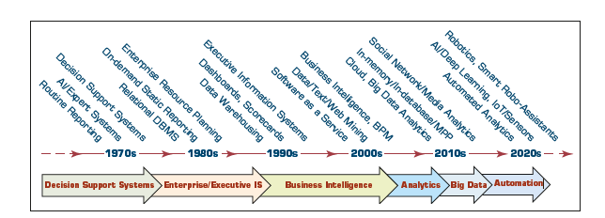

The figure in this section presents a **timeline** showing the progression from:  
**MIS → DSS → EIS/OLAP → BI → Analytics/Data Science**,  
highlighting increased **scope, interactivity, and analytical sophistication** at each stage.

**A Framework for Business Intelligence (BI)**

**Introduction**

Business Intelligence (BI) refers to a set of **processes, architectures, and technologies** that convert raw data into meaningful information for business purposes.  
A BI framework provides the **structure** for understanding and implementing BI initiatives in organizations, ensuring alignment with strategic goals.

**Definitions of BI**

* BI is an **umbrella term** combining architectures, tools, databases, analytical tools, applications, and methodologies.
* It enables **interactive access** to data, manipulation of data, and the transformation of data into **useful information**.
* BI supports decision making by providing **timely, relevant, and accurate** information.
* **Key characteristics**: user-centered, data-driven, and often includes predictive and prescriptive components.

**A Brief History of BI**

* The concept of BI dates back to the **1970s** with the development of **Decision Support Systems (DSS)**.
* The 1980s saw **Executive Information Systems (EIS)** for top-level managers.
* The 1990s marked the rise of **data warehousing and OLAP**.
* Early 2000s introduced **dashboards, scorecards, and performance management**.
* Today’s BI integrates **big data analytics, AI, and machine learning** for advanced decision support.

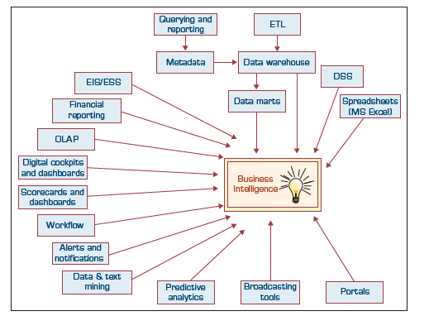

**The Architecture of BI**

A typical BI architecture includes:

1. **Data Sources** – internal (transaction systems, ERP) and external (market data, social media).
2. **Data Integration Layer** – ETL (Extract, Transform, Load) processes.
3. **Data Warehousing** – centralized data repository.
4. **Business Analytics** – OLAP, data mining, predictive modeling.
5. **Presentation Layer** – dashboards, reports, scorecards.

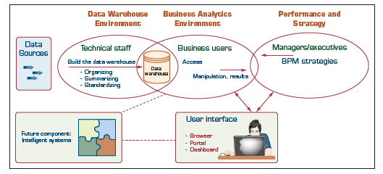

**Diagram Explanation**: The architecture is often depicted as layered — data sources at the bottom, processing in the middle, and presentation tools at the top, enabling flow from raw data to actionable insights.

**The Origins and Drivers of BI**

* Originated from the need to make better, faster decisions in **increasingly complex environments**.
* **Key drivers**:
  + Global competition
  + Need for customer-centric strategies
  + Explosion of data volumes and sources
  + Technological advances enabling large-scale analytics

**A Multimedia Exercise in Business Intelligence**

* This section uses a multimedia example to demonstrate how BI tools can be applied in **real-world decision-making scenarios**.
* Shows the **interactive and visual capabilities** of BI systems.

**Transaction Processing versus Analytic Processing**

* **Transaction Processing (OLTP)**: Handles day-to-day operational data (e.g., sales transactions, banking withdrawals). Focuses on efficiency and accuracy.
* **Analytic Processing (OLAP)**: Focuses on analysis of data to support decision making. Enables multidimensional views of data.

**Appropriate Planning and Alignment with the Business Strategy**

* BI projects must be **aligned with the organization’s strategic objectives**.
* Requires thorough planning involving **business and IT stakeholders**.
* Misalignment leads to poor ROI and underutilization of BI tools.

**Real-Time, On-Demand BI Is Attainable**

* Advances in hardware, in-memory analytics, and data streaming make **real-time BI** possible.
* Benefits include instant access to insights, faster reaction to market changes, and improved operational agility.

**Developing or Acquiring BI Systems**

* Organizations must decide whether to **build in-house** or **purchase** BI solutions.
* Considerations:
  + Cost
  + Time to deploy
  + Scalability
  + Vendor support

**Justification and Cost–Benefit Analysis**

* BI investments should be evaluated using:
  + Quantitative benefits (cost savings, increased revenue)
  + Qualitative benefits (improved customer satisfaction, better decision making)
* A proper cost–benefit analysis helps secure executive buy-in.

**Security and Protection of Privacy**

* BI systems must ensure **data confidentiality, integrity, and availability**.
* Compliance with data protection laws (e.g., GDPR, HIPAA) is critical.
* Techniques include encryption, access control, and auditing.

**Integration of Systems and Applications**

* BI tools often need to integrate with:
  + ERP systems
  + CRM applications
  + Supply chain systems
* Seamless integration improves data consistency and eliminates silos.

**Analytics Overview**

**Introduction**

Analytics refers to the **scientific process of transforming data into insight** for making better decisions.  
It is a key component of Business Intelligence (BI) and includes **descriptive, predictive, and prescriptive** methods.  
Analytics can be applied across industries for operational, tactical, and strategic decision-making.

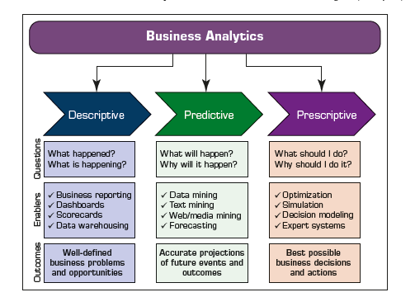

**Descriptive Analytics**

**Definition**

* Descriptive analytics answers the question: **“What happened?”**
* Uses historical data to understand trends and patterns.

**Techniques**

* Standard reporting
* Dashboards and scorecards
* OLAP for multidimensional data exploration

**Example**

Analyzing last quarter’s sales to identify top-performing products.

**Predictive Analytics**

**Definition**

* Predictive analytics answers: **“What is likely to happen?”**
* Uses historical data along with statistical, data mining, and machine learning models.

**Techniques**

* Regression analysis
* Classification models
* Time-series forecasting

**Example**

Forecasting customer churn based on behavioral and demographic data.

**Analytics in Action 1.2: Silvaris Increases Business with Visual Analysis and Real-Time Reporting Capabilities**

**Case Summary**

* **Company**: Silvaris, a wholesale distributor of building materials.
* **Problem**: Needed faster, more visual access to business data.
* **Solution**: Adopted BI tools for real-time dashboards and visual analytics.
* **Results**: Improved sales tracking, enhanced decision-making, and increased operational efficiency.

**Prescriptive Analytics**

**Definition**

* Prescriptive analytics answers: **“What should we do?”**
* Recommends actions based on optimization and simulation models.

**Techniques**

* Optimization algorithms
* Decision analysis
* Simulation

**Example**

Recommending optimal pricing strategies to maximize profit given market demand forecasts.

**Analytics in Action 1.3: How Big Will Be the Beef? Understanding Animals’ Eating Behavior and Their Final Weight**

**Case Summary**

* **Objective**: Predict final weight of cattle to improve supply chain efficiency.
* **Approach**: Used sensor data to track feeding behavior and integrated it with predictive models.
* **Results**: Improved accuracy in predicting market readiness, reducing waste and costs.

**The Modeling Process and Results**

**Steps**

1. Define the problem and objectives.
2. Collect and prepare data.
3. Develop and test models.
4. Deploy models and monitor results.

**Key Point**

Modeling is iterative — models are refined as new data and feedback become available.

**Analytics in Action 1.4: A Specialty Steel Bar Company Uses Analytics to Determine Available-to-Promise Dates**

**Case Summary**

* **Problem**: Needed to provide accurate delivery dates for custom steel orders.
* **Solution**: Implemented analytics-based scheduling and production planning.
* **Results**: Increased customer satisfaction and improved production efficiency.

**Analytics/Data Science/Machine Learning/AI?**

**Relationship**

* **Analytics**: Broader process of deriving insights from data.
* **Data Science**: Combines statistics, programming, and domain knowledge to solve data-driven problems.
* **Machine Learning**: A subset of AI focusing on algorithms that learn from data.
* **AI**: Broader field enabling machines to mimic human intelligence.

**Integration**

Modern BI systems integrate all four areas to provide comprehensive decision support.